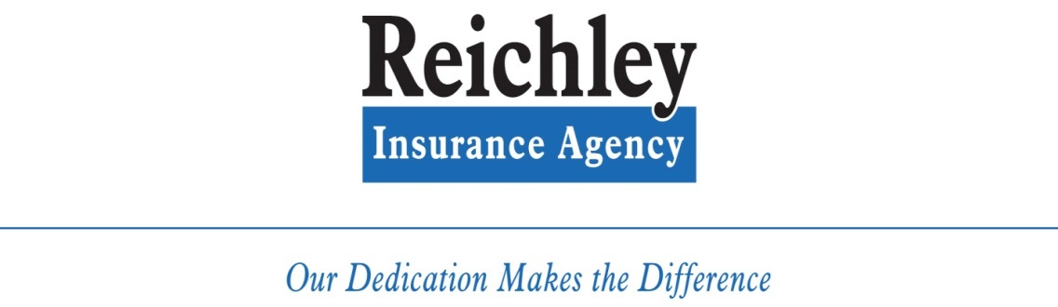
Perk Reichley | President | 937-306-8007 | Perk@reichleyins.com
Pat Ashworth | Personal Lines | 937-306-8002 | Pat@reichleyins.com
Vicki Cook | Personal Lines | 937-306-8006 | Vicki@reichleyins.com
Liz Myers | Commercial Lines | 937-306-8003 | Liz@reichleyins.com
Patti Drake | Commercial Lines | 937-306-8004 | Patti@reichleyins.com
Randy Gifford | Life & Health | 937-347-6003 | Randy@reichleyins.com
Carrie Gifford | Life & Health | 937-347-6002 | Carrie@reichleyins.com
Alex Wright | Receptionist | 937-306-8005 | Alex@reichleyins.com
Main Line: 937-429-0655  Fax Line: 937-426-4642  24 Hour Claim Services |  | Address: 2440 Dayton Xenia Rd.  Beavercreek, OH 45434

